**SPAM MAIL DETECTION USING**

**NAÏVE BAYES CLASSIFIER**

## A PROJECT REPORT

***Submitted by***

**ABISHEAK A (202109004)**

**KARPAGA GANESH B (202109027)**

**MANOJ S (202109032)**

***In partial fulfilment for the award of the degree***

### of

**BACHELOR OF ENGINEERING**

### in

**ARTIFICIAL INTELLIGENCE AND DATA SCIENCE**

### MEPCO SCHLENK COLLEGE OF ENGINEERING, SIVAKASI-626123

**(An Autonomous Institution) ANNA UNIVERSITY: CHENNAI 600 025**

**MAY 2023**

**MEPCO SCHLENK ENGINEERING COLLEGE, SIVAKASI**

**AUTONOMOUS**

**DEPARTMENT OF ARTIFICIAL INTELLIGENCE AND DATASCIENCE**

**BONAFIDE CERTIFICATE**

This is to certify that it is the bonafide work of **“AbisheakA(9517202109004), karpaga Ganesh (9517202109027), Manoj S(9517202109032)”** for the mini project titled **“SPAM MAIL DETECTION USING NAÏVE BAYES CLASSIFIER”** in 19AD451 – Data Analytics Laboratory and 19AD452- Artificial Intelligence Laboratory during the fourth semester January 2023 – May 2023 under my supervision.

**SIGNATURE              SIGNATURE**

**Dr.P.Thendral, M.E.,Ph.D, Dr.J.AngelaJennifaSujana, M.E.,Ph.D,**

**Assistant Professor(SG), Associate Professor(SG) & Head,**

Artificial Intelligence and Data Science,   Artificial Intelligence and Data Science ,

MepcoSchlenk Engineering College, MepcoSchlenk Engineering College,

Sivakasi- 626 005,Virudhunagar. Sivakasi- 626 005,Virudhunagar.

Submitted for the project viva-voice examination to be held on ………

**INTERNAL EXAMINER** **EXTERNAL EXAMINER**

**MEPCO SCHLENK ENGINEERING COLLEGE, SIVAKASI**

**AUTONOMOUS**

**DEPARTMENT OF ARTIFICIAL INTELLIGENCE AND DATASCIENCE**

**BONAFIDE CERTIFICATE**

This is to certify that it is the bonafide work of “**AbisheakA(9517202109004), karpaga Ganesh (9517202109027), Manoj S(9517202109032)”** for the mini project titled **“SPAM MAIL DETECTION USING NAÏVE BAYES CLASSIFIER”** in 19AD451 – Data Analytics Laboratory and 19AD452- Artificial Intelligence Laboratory during the fourth semester January 2023 – May 2023 under my supervision.

**SIGNATURE              SIGNATURE**

**Dr.A.Shenbagarajan, M.E.,Ph.D Dr.J.AngelaJennifaSujana, M.E.,Ph.D,**

**Assistant Professor(SG), Associate Professor(SG) & Head,**

Artificial Intelligence and Data Science,    Artificial Intelligence and Data Science ,

MepcoSchlenk Engineering College, MepcoSchlenk Engineering College,

Sivakasi- 626 005,Virudhunagar. Sivakasi- 626 005,Virudhunagar.

Submitted for the project viva-voice examination to be held on ……….

**INTERNAL EXAMINER** **EXTERNAL EXAMINER**

**ACKNOWLEDGEMENT**

First and foremost we **praise and thank “The Almighty”,** the lord of all creations, who by his abundant grace has sustained us and helped us to work on this project successfully.

We really find unique pleasure and immense gratitude in thanking our respected management members**,** who is the backbone of our college.

A deep bouquet of thanks to respected Principal **Dr.S.Arivazhagan M.E.,Ph.D.,** for having provided the facilities required for our mini project.

We sincerely thank our Head of the Department **Dr. J. Angela JennifaSujana M.E.,Ph.D.,** Associate Professor(SG) & Head, Department of Artificial Intelligence and Data Science, for her guidance and support throughout the mini project .

We also thank our guide **Dr.A.Shenbagarajan.,M.E.,Ph.D.,** Assistant Professor(SG), **Mrs.P.Thendral., M.E(Ph.D)**, Assistant Professor(SG) Department of Artificial Intelligence and Data Sciencefor their valuable guidance and it is great privilege to express our gratitude to them.

We extremely thank our project coordinator **Dr.A.Shenbagarajan.,M.E.,Ph.D.,** Assistant Professor(SG),**Mrs.P.Thendral, M.E(Ph.D),** Assistant Professor(SG)Department of Artificial Intelligence and Data Science, who inspired us and supported us throughout the mini project.

We extend our heartfelt thanks and profound gratitude to all the faculty members of Artificial Intelligence and Data Science department for their kind help during our mini project work.

We also thank our parents and our friends who had been providing us with constant support during the course of the mini project work.

**TABLE OF CONTENTS**

| **CHAPTER NO** | **TITLE** | | **PAGE NO.** |
| --- | --- | --- | --- |
|  | LIST OF FIGURE  ABSTRACT | | 6 |
|  | 8 |
| 1 | INTRODUCTION | |  |
|  | 1.1 | Scope of the project | 10 |
|  | 1.2 | Objective | 10 |
|  | 1.3 | Block Diagram | 10 |
|  | 1.4 | Module Description | 11 |
|  | 1.5 | Graphical User Interface | 12 |
| 2 | PROPOSED MODEL | | 14 |
|  | 2.1 | Data Set Description | 15 |
|  | 2.2 | Data Analytics Functionalities | 16 |
| 3 | AI FUNCATIONALITIES | | 19 |
| 4 | IMPLEMENTATION | |  |
|  | 4.1 | Source Code | 27 |
|  | 4.2 | Results | 30 |
| 5 | CONCLUSION | | 31 |
| 6 | BIBLIOGRAPHY | | 32 |

**LIST OF FIGURES**

| **F.NO** | **TITLE** | **PAGE NO.** |
| --- | --- | --- |
| 1.3.1 | Block Diagram | 10 |
| 1.4.1 | Importing Module | 12 |
| 1.5.1 | GUI for reading CSV | 13 |
| 1.5.2 | GUI for displaying Result | 13 |
| 2.1 | Model Diagram | 14 |
| 2.2.2.1 | shape | 16 |
| 2.2.2.2 | head | 16 |
| 2.2.2.3 | tail | 17 |
| 2.2.2.4 | info | 17 |
| 2.2.2.5 | describe | 17 |
| 2.2.3 | Histogram | 18 |
| 3.3.1 | Naïve Bayes Result | 19 |
| 3.3.2 | Naïve Bayes Confusion Matrix | 20 |
| 3.4.1 | Logistic Regression Result | 20 |
| 3.4.2 | Logistic Regression Confusion Matrix | 21 |
| 3.5.1 | Decision Tree Classifier Result | 21 |
| 3.5.2 | Decision Tree Visualization | 22 |
| 3.6 | Knn Result | 23 |
| 3.7 | Random Forest Result | 24 |
| 3.8.1 | SVM Result | 25 |
| 3.8.2 | SVM Confusion Matrix | 25 |
| 3.9 | Classification Report | 26 |
| 4.2.1 | Result 1 | 30 |
| 4.2.2 | Result 2 | 30 |

# ABSTRACT

Spam mail detection is a critical task in ensuring the security and efficiency of email communication systems. This project aims to develop a spam mail detection system using the Naive Bayes classifier. The Naive Bayes algorithm is a popular and efficient probabilistic model that leverages the principles of conditional probability to classify emails as spam or non-spam.

The project begins by creating a dataset comprising a collection of labeled emails, including both spam and non-spam examples. The emails are preprocessed to extract relevant features such as the frequency of specific words, presence of certain patterns, and structural characteristics. These features serve as inputs to the Naive Bayes classifier.

The Naive Bayes classifier is trained on the preprocessed dataset to learn the underlying probability distribution of features associated with spam and non-spam emails. During the training process, the classifier calculates the conditional probabilities of each feature given the class labels. This information is then utilized to classify new, unseen emails as either spam or non-spam.

To evaluate the effectiveness of the spam mail detection system, various performance metrics such as accuracy, precision, recall, and F1 score are computed. The trained classifier is tested on a separate evaluation dataset to measure its ability to correctly classify emails. The results of the evaluation provide insights into the system's performance and can guide further improvements.

The project also explores techniques to enhance the accuracy of spam mail detection. Feature selection methods and parameter tuning are investigated to optimize the performance of the Naive Bayes classifier. Additionally, the project examines the impact of different preprocessing techniques, such as stemming and stop-word removal, on the overall performance of the system.

The experimental results demonstrate the efficacy of Naive Bayes classifier in detecting spam mails. The system achieves high accuracy and exhibits robustness against different types of spam emails. The project contributes to field of email security by providing a practical and efficient approach for identifying and filtering out spam mails, thereby improving the overall user experience and reducing the risks associated with malicious email content.

**CHAPTER 1**

**INTRODUCTION**

Spam mail detection is a crucial task for ensuring the security and efficiency of email communication systems. This project aims to develop a spam mail detection system using the Naive Bayes classifier, a popular and efficient probabilistic model that leverages conditional probability principles to classify emails as either spam or non-spam.

The project commences with the creation of a dataset consisting of labeled emails, encompassing both spam and non-spam examples. These emails undergo preprocessing to extract pertinent features, such as word frequency, pattern presence, and structural characteristics. These extracted features are utilized as inputs for the Naive Bayes classifier.

Subsequently, the Naive Bayes classifier is trained on the preprocessed dataset to learn the underlying probability distribution of features associated with spam and non-spam emails. During the training process, the classifier calculates the conditional probabilities of each feature given the class labels. This information is then used to classify new, unseen emails as either spam or non-spam.

To evaluate the effectiveness of the spam mail detection system, various performance metrics, including accuracy, precision, recall, and F1 score, are computed. The trained classifier is tested on a separate evaluation dataset to assess its ability to correctly classify emails. The evaluation results provide insights into the system's performance and can guide further improvements.

The project also explores techniques to enhance the accuracy of spam mail detection. It investigates feature selection methods and parameter tuning to optimize the performance of the Naive Bayes classifier. Additionally, the impact of different preprocessing techniques, such as stemming and stop-word removal, on the overall system performance is examined.

The experimental results demonstrate the effectiveness of the Naive Bayes classifier in detecting spam emails. The system achieves high accuracy and exhibits robustness against various types of spam. The project contributes to the field of email security by providing a practical and efficient approach to identify and filter out spam mails, thereby improving the user experience and reducing the risks associated with malicious email content.

.

### 1.1 SCOPE OF THE PROJECT

The scope of the spam detection project involves the development and evaluation of a spam mail detection system Preprocessing the emails to extract relevant features, such as word frequency, pattern presence, and structural characteristics. Techniques like tokenization, stop-word removal, stemming, and pattern matching may be employed

### 1.2 OBJECTIVE OF THE PROJECT

The objective of the spam mail detection project is to develop a robust and efficient system for accurately identifying and classifying spam emails. To create a system that can effectively distinguish between spam and non-spam emails.

**1.3 BLOCK DIAGRAM**

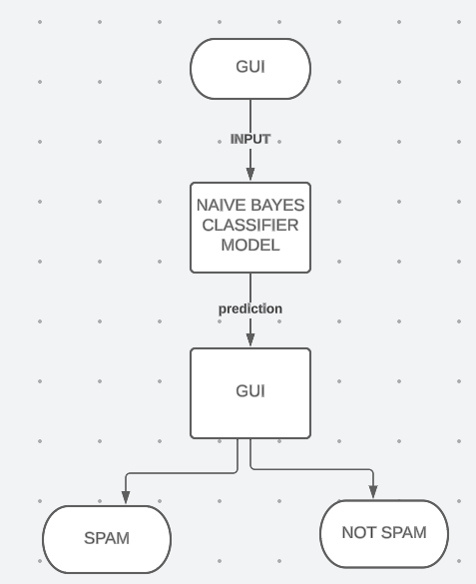

**Fig.1.3.1 Block diagram**

**1.4 MODULE DESCRIPTION**

**1.4.1GRADIO**

Gradio is an open-source Python package that allows you to quickly create easy-to-use, customizable UI components for your ML model, any API, or even an arbitrary Python function using a few lines of code. You can integrate the Gradio GUI directly into your Jupyter notebook or share it as a link with anyone.

**1.4.2 COUNTVECTROZIER**

Scikit-learn'sCountVectorizer is used to convert a collection of text documents to a vector of term/token counts. It also enables the ​pre-processing of text data prior to generating the vector representation. This functionality makes it a highly flexible feature representation module for text.

**1.4.3 MULTINOMIALNB**

MultinomialNB implements the naive Bayes algorithm for multinomially distributed data, and is one of the two classic naive Bayes variants used in text classification where the data are typically represented as word vector counts.

**1.4.4 MATPLOTLIB**

Matplotlib is a comprehensive library for creating static, animated,and interactive visualizations in Python. Matplotlib makes easy thingseasy and hard things possible. Createpublication quality plots. Makeinteractive figuresthat can zoom, pan, update. Customizevisual styleandlayout.

**1.4.5 SEABORN**

Matplotlib is an amazing visualization library in Python for 2D plots of arrays. Matplotlib is a multi-platform data visualization library built on NumPy arrays and designed to work with the broader SciPy stack

**1.4. PANDAS**

Pandas is an open-source library that is made mainly for working with relational or labeled data both easily and intuitively. It provides various data structures and operations for manipulating numerical data and time series. This library is built on top of the NumPy library. Pandas is fast and it has high performance & productivity for users.

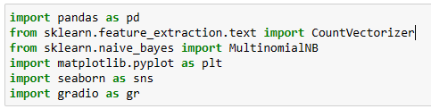

**Fig.1.4.1 Importing Module**

**1.5 GRAPHICAL USER INTERFACE**

A graphical user interface (GUI) is an interface that is drawn on the screen for the user to interact with. User interfaces have some common components: Main window. Menu.

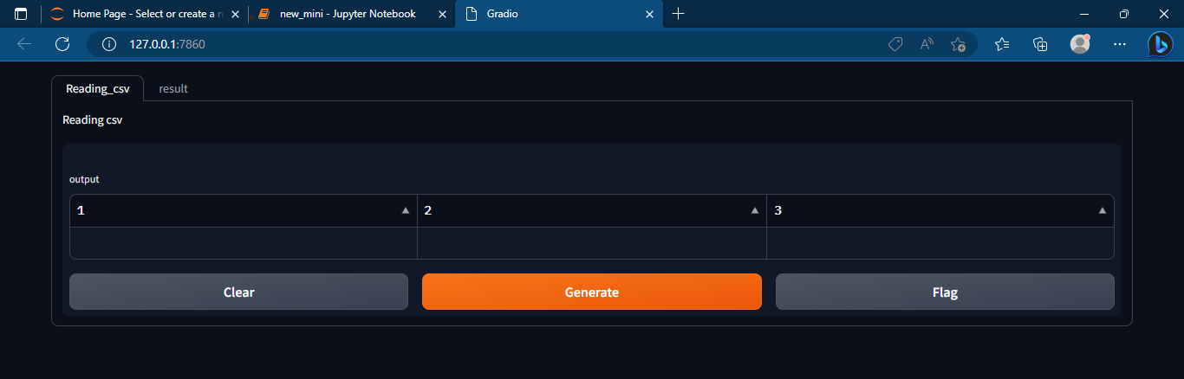

**Fig.1.5.1 GUI for reading the csv file**

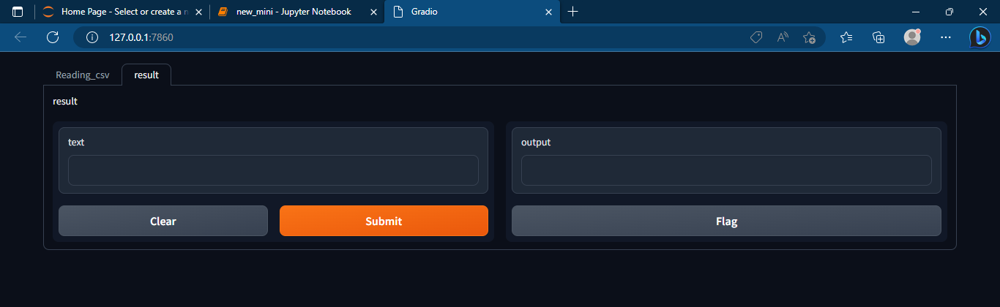

**Fig.1.5.2 GUI for displaying the result**

**CHAPTER 2**

**PROPOSED MODEL**

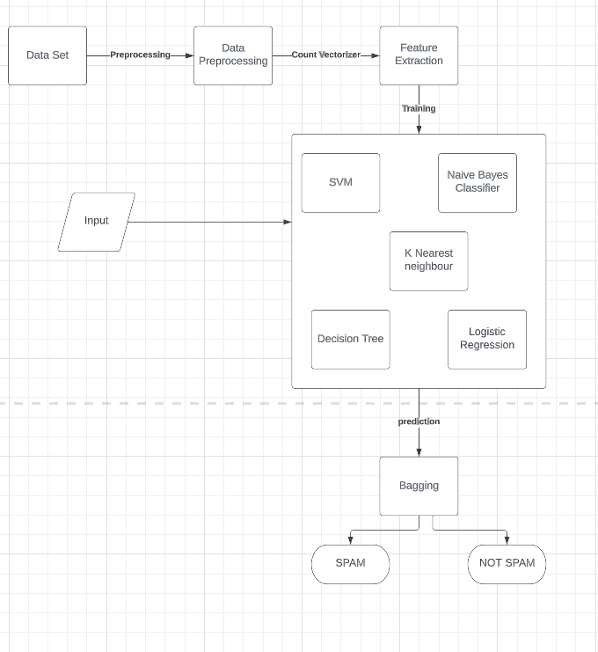

**Fig. 2.1 Model Diagram**

**2.1 DATASET DESCRIPTION**

**Context**

       The SMS Spam Collection is a set of SMS tagged messages that have been collected for SMS Spam research. It contains one set of SMS messages in English of 5,171 messages, tagged according being ham (legitimate) or spam.

**Content**

·        Untitled: Notation of ham or spam

·        Text: Sample mails

·        Label_num:  class variable (0 or 1)

Number of  instances: 5171

Number  of attributes: 2 + class attribute

Missing Attribute Values: No

Class  Distribution : class value 1 is interpreted as “SPAM”  and class value 0 is interpreted as “NOT SPAM”

**2.2 DATA ANALYTICS FUNCTIONAITIES**

**2.2.1 Reading CSV:**

The code reads a CSV file named 'spam_ham_dataset.csv' using the Pandas library's read_csv() function.

**2.2.2 Exploring Data:**

The code displays the shape of the dataset (data.shape), the first few rows (data.head()), the last few rows (data.tail()), and the summary information of the dataset data.info() and data.describe().

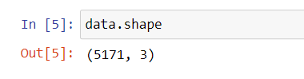

**Fig.2.2.2.1 Shape**

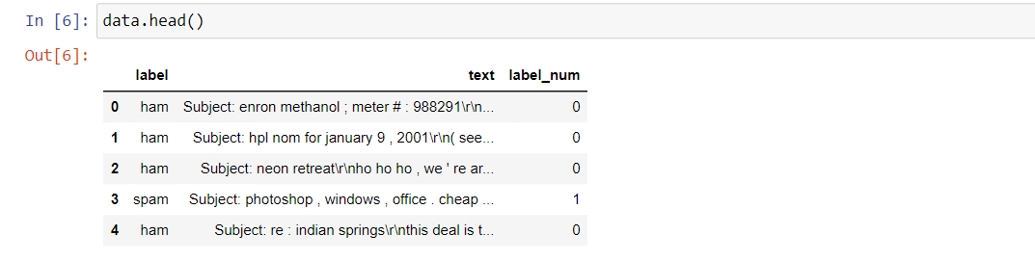

**Fig.2.2.2.2 head()**

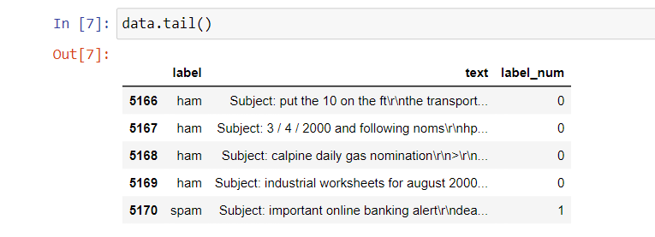

**Fig.2.2.2.3 Tail()**

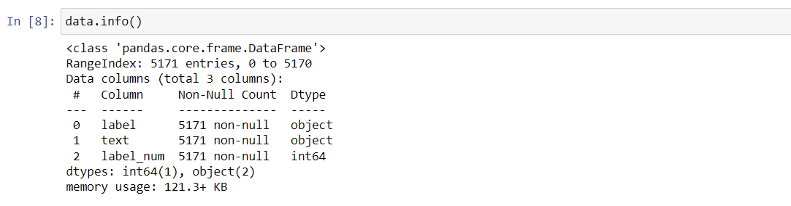

**Fig.2.2.2.4 info()**

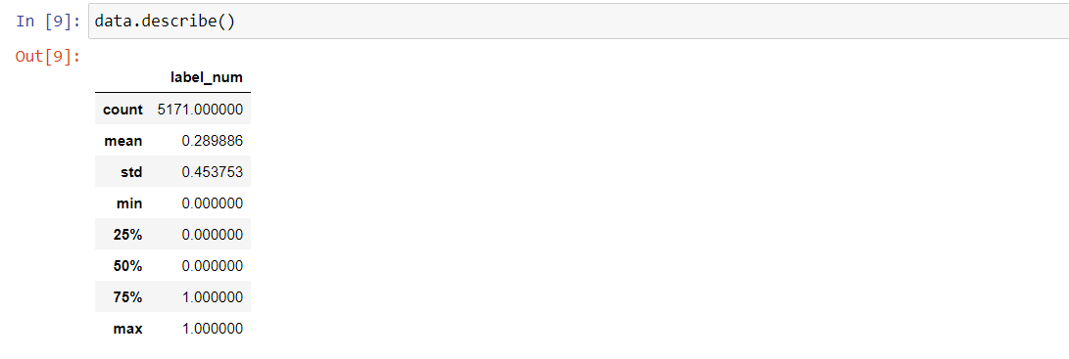

**Fig.2.2.2.5 describe()**

**2.2.3 Data Visualization:**

The code creates a histogram of the 'label' column using Matplotlib's hist() function. It also uses Seaborn'sheatmap() function to visualize the confusion matrices generated by different classifiers.

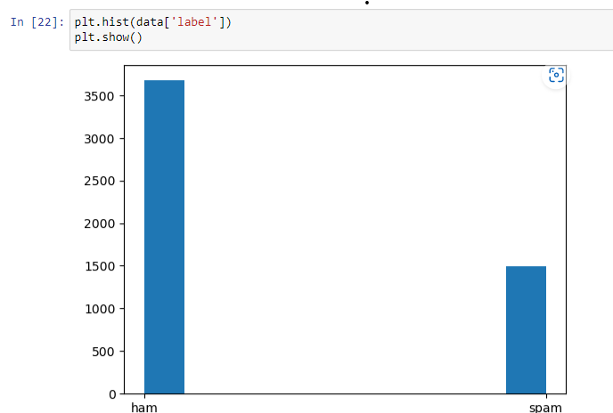

**Fig.2.2.3 Histogram**

**CHAPTER 3**

**ARTIFICIAL INTELLIGENCE FUNCTIONALITIES**

**3.1 Text Vectorization:**

The code uses Scikit-learn'sCountVectorizer() to convert text data into numerical feature vectors (spamham_countVectorizer).

fromsklearn.feature_extraction.textimportCountVectorizer

vectorizer=CountVectorizer()

spamham_countVectorizer=vectorizer.fit_transform(data['text'])

**3.2 Splitting Data:**

The code splits the dataset into training and testing sets using Scikit-learn'strain_test_split() function.

fromsklearn.model_selectionimporttrain_test_split,cross_val_score

X_train,X_test,Y_train,Y_test=train_test_split(X,y,test_size=0.2)

**3.3 Naive Bayes Classifier:**

The code trains a Multinomial Naive Bayes classifier (MultinomialNB()) on the training data and makes predictions on the testing data.

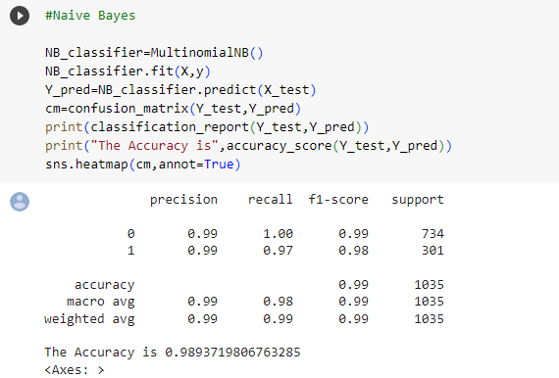

**Fig 3.3.1 Naïve Bayes Classifier Result**

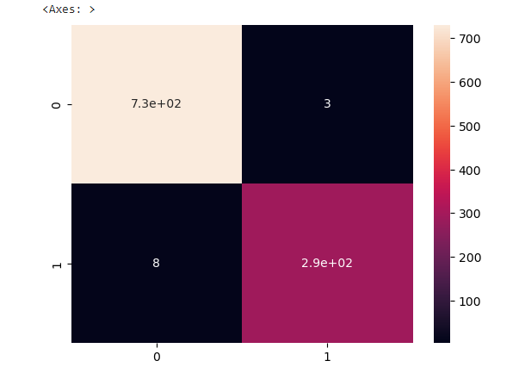

**Fig.3.3.2 Naïve bayes Classifier Confusion Matrix**

**3.4 Logistic Regression:**

The code trains a Logistic Regression classifier (LogisticRegression()) on the training data and makes predictions on the testing data.

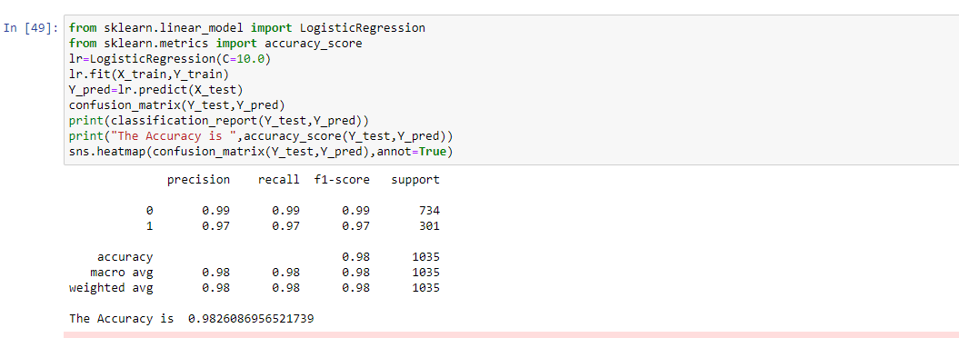

**Fig.3.4.1 Logistic Regression Result**

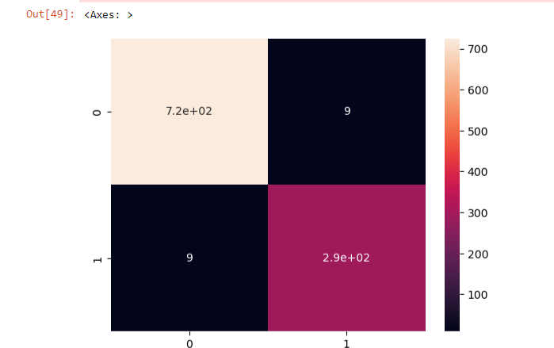

**Fig.3.4.2 Logistic Regression Confusion Matrix**

**3.5 Decision Tree Classifier:**

The code trains a Decision Tree classifier (DecisionTreeClassifier()) on the training data and makes predictions on the testing data.

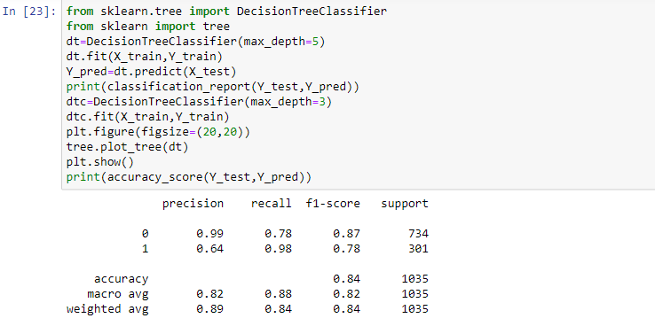

**Fig. 3.5.1 Decision Tree Result**

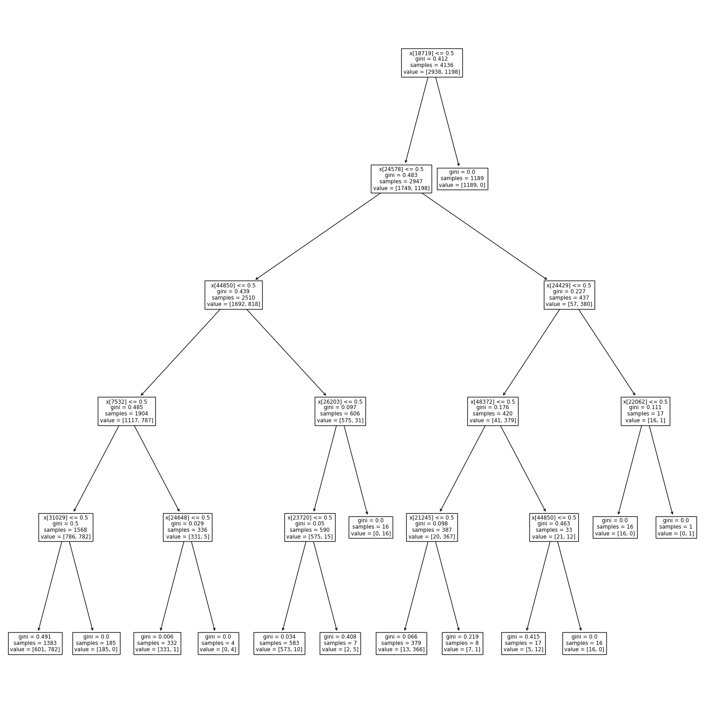

**Fig.3.5.2 Decision Tree visualization**

**3.6 K-Nearest Neighbors Classifier:**

The code trains a K-Nearest Neighbors classifier (KNeighborsClassifier()) on the training data and makes predictions on the testing data.

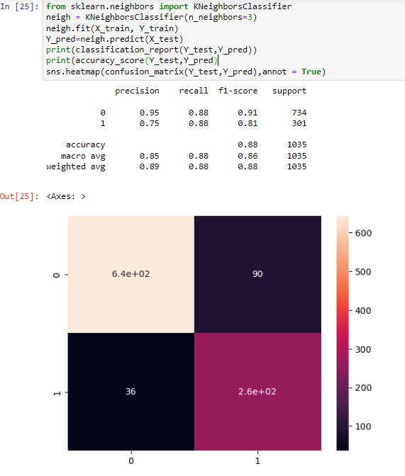

**Fig.3.6 Knn Result**

**3.7 Random Forest:**

Random Forest is an ensemble learning method that combines multiple decision trees to create a more robust and accurate predictive model. It is a supervised learning algorithm used for both classification and regression tasks.

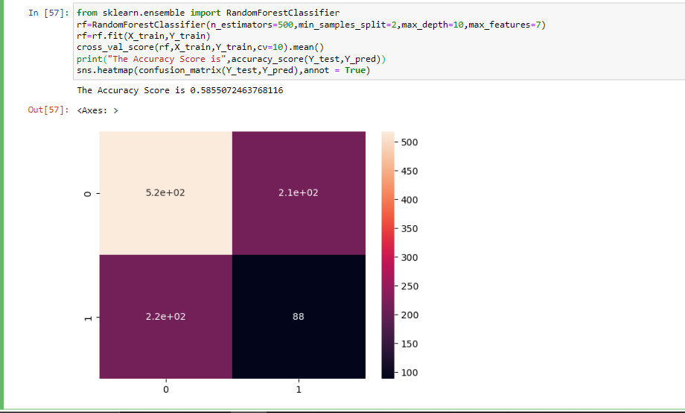

**Fig.3.7 Random Forest report**

**3.8 SVM**

SVM (Support Vector Machines) is a supervised machine learning algorithm used for classification and regression tasks. It is a powerful algorithm that can handle both linear and non-linear relationships between variables.

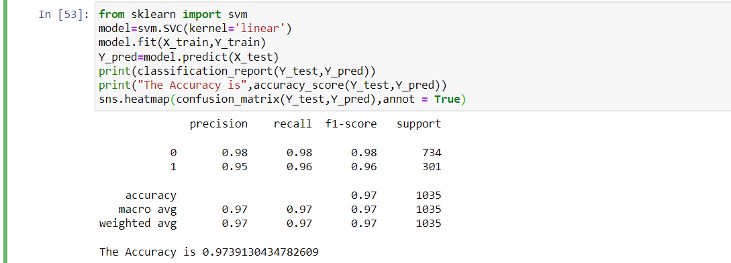

**Fig.3.8.1 SVM Result**

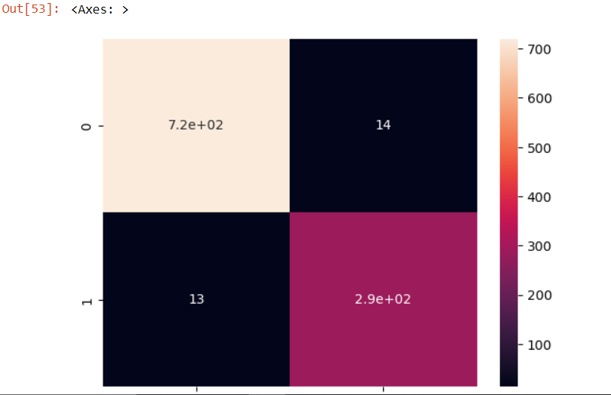

**Fig.3.8.2 SVM Confusion Matrix**

**3.9 Classification Reports:**

The code generates classification reports using Scikit-learn'sclassification_report() function to evaluate the performance of the classifiers.

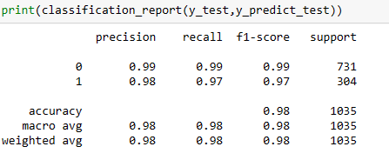

**3.9 classification Report**

**3.10 Accuracy Scores:**

The code calculates accuracy scores using Scikit-learn'saccuracy_score() function to measure the accuracy of the classifiers.

fromsklearn.metricsimportclassification_report,confusion_matrix,accuracy_score

**3.11 Confusion Matrix Visualization:**

The code uses Seaborn'sheatmap() function to visualize the confusion matrices generated by the classifiers.

fromsklearn.metricsimportclassification_report,confusion_matrix,accuracy_score

**CHAPTER 4**

**IMPLEMENTATION**

**4.1 SOURCE CODE**

import pandas aspd

fromsklearn.feature_extraction.textimportCountVectorizer

fromsklearn.naive_bayesimportMultinomialNB

importmatplotlib.pyplotasplt

importseabornassns

importgradioas gr

ds = pd.read_csv('spam_ham_dataset.csv')

ds

defdata_set():

    spam_df  =pd.read_csv('spam_ham_dataset.csv')

    returnspam_df.drop('Unnamed: 0',axis=1)

data = data_set()

data

data.shape

data.tail()

data.info()

data.describe()

plt.hist(data['label'])

plt.show()

fromsklearn.feature_extraction.textimportCountVectorizer

vectorizer=CountVectorizer()

spamham_countVectorizer=vectorizer.fit_transform(data['text'])

label=data['label_num']

X=spamham_countVectorizer

y=label

fromsklearn.model_selectionimporttrain_test_split,cross_val_score

fromsklearn.metricsimportclassification_report,confusion_matrix,accuracy_score

X_train,X_test,Y_train,Y_test=train_test_split(X,y,test_size=0.2)

#Naive Bayes

NB_classifier=MultinomialNB()

NB_classifier.fit(X,y)

Y_pred=NB_classifier.predict(X_test)

cm=confusion_matrix(Y_test,Y_pred)

print(classification_report(Y_test,Y_pred))

print("The Accuracy is",accuracy_score(Y_test,Y_pred))

sns.heatmap(cm,annot=True)

fromsklearn.linear_modelimportLogisticRegression

fromsklearn.metricsimportaccuracy_score

lr=LogisticRegression(C=10.0)

lr.fit(X_train,Y_train)

Y_pred=lr.predict(X_test)

confusion_matrix(Y_test,Y_pred)

print(classification_report(Y_test,Y_pred))

print("The Accuracy is ",accuracy_score(Y_test,Y_pred))

sns.heatmap(confusion_matrix(Y_test,Y_pred),annot=True)

fromsklearn.treeimportDecisionTreeClassifier

fromsklearnimport tree

dt=DecisionTreeClassifier(max_depth=5)

dt.fit(X_train,Y_train)

Y_pred=dt.predict(X_test)

print(classification_report(Y_test,Y_pred))

dtc=DecisionTreeClassifier(max_depth=3)

dtc.fit(X_train,Y_train)

plt.figure(figsize=(20,20))

tree.plot_tree(dt)

plt.show()

print("The Accuracy is",accuracy_score(Y_test,Y_pred))

fromsklearn.neighborsimportKNeighborsClassifier

neigh = KNeighborsClassifier(n_neighbors=3)

neigh.fit(X_train, Y_train)

Y_pred=neigh.predict(X_test)

print(classification_report(Y_test,Y_pred))

print("The Accuracy is",accuracy_score(Y_test,Y_pred))

sns.heatmap(confusion_matrix(Y_test,Y_pred),annot = True)

fromsklearnimportsvm

model=svm.SVC(kernel='linear')

model.fit(X_train,Y_train)

Y_pred=model.predict(X_test)

print(classification_report(Y_test,Y_pred))

print("The Accuracy is",accuracy_score(Y_test,Y_pred))

sns.heatmap(confusion_matrix(Y_test,Y_pred),annot = True)

fromsklearn.ensembleimportRandomForestClassifier

rf=RandomForestClassifier(n_estimators=500,min_samples_split=2,max_depth=10,max_features=7)

rf=rf.fit(X_train,Y_train)

cross_val_score(rf,X_train,Y_train,cv=10).mean()

print("The Accuracy Score is",accuracy_score(Y_test,Y_pred))

sns.heatmap(confusion_matrix(Y_test,Y_pred),annot = True)

defcheck(text):

    a= []

    df =data_set()

    X = df['text']

    y = df['label_num']

    vectorizer=CountVectorizer()

    X = vectorizer.fit_transform(X)

    new_email_features = vectorizer.transform([text])

    model = MultinomialNB()

    model.fit(X, y)

    prediction = model.predict(new_email_features)

    a.append(prediction[0])

    dt=DecisionTreeClassifier(max_depth=5)

    dt.fit(X,y)

    prediction = dt.predict(new_email_features)

    a.append(prediction[0])

    lr=LogisticRegression(C=10.0)

    lr.fit(X,y)

    prediction = lr.predict(new_email_features)

    a.append(prediction[0])

    neigh = KNeighborsClassifier(n_neighbors=3)

    neigh.fit(X,y)

    prediction = neigh.predict(new_email_features)

    a.append(prediction[0])

    model=svm.SVC(kernel='linear')

    model.fit(X,y)

    prediction=model.predict(new_email_features)

    a.append(prediction[0])

    ifa.count(0) <a.count(1):

        return"The email is spam!"

    else:

        return"The email is not spam."

app1 = gr.Interface(fn=data_set,inputs=None, outputs=gr.Dataframe(),description="Reading csv")

app3 = gr.Interface(fn=check, inputs='text', outputs='text',description=" result")

demo = gr.TabbedInterface([app1, app3], ["Reading_csv", "result"])

demo.launch()

**4.2 RESULT**

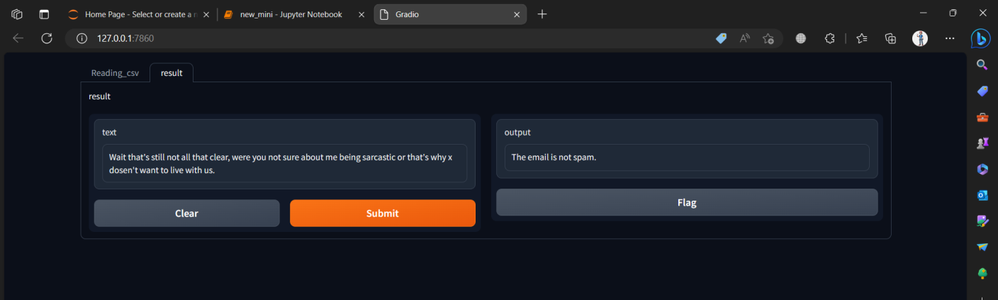

**Fig.4.2.1 Result 1**

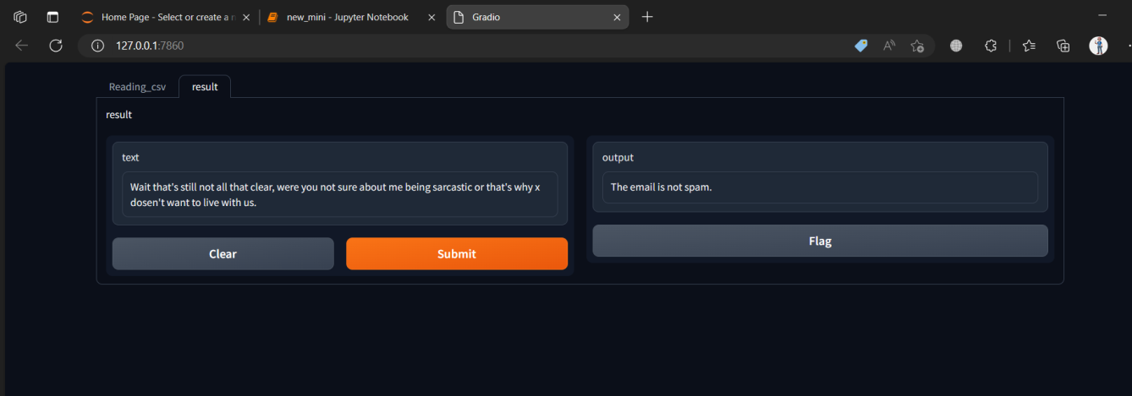

**Fig.4.2.2 Result 2**

**CHAPTER 5**

**CONCLUSION**

In conclusion, this project provides a solid foundation for spam mail detection using the Naive Bayes classifier. The developed system showcases promising results and serves as a starting point for future advancements in the field. By incorporating more sophisticated techniques and exploring additional features, we can continue to improve the accuracy and efficiency of spam mail detection systems, thereby contributing to a safer and more reliable email communication environment.

**CHAPTER 6**

**BIBLIOGRAPHY**

1. https://www.geeksforgeeks.org/using-countvectorizer-to-extracting-features-from-text/
2. https://www.javatpoint.com/fit-transform-and-fit_transform-methods-in-python
3. https://gradio.app/docs/
4. https://www.javatpoint.com/machine-learning-naive-bayes-classifier
5. http://scikit-learn.org/stable/modules/generated/sklearn.naive_bayes.MultinomialNB.html